**Aim: -** To study HTML Formatting tags.

**Tags:**

**1.**<b>

**2.**<i>

**3.**<u>

**4.**<sub>

**5.**<sup>

**6.**<del>/<strike>

**7.** <bdo>

**8.** <pre>

**9.** <center>

**10.**<blockquote>

**Exercises:**

**1.**Write a HTML Code to display a message “**Understanding** is the first step to ***acceptance***, and only with acceptance can there be ***recovery***.”

**2.**Write a HTML Code to display a message “**H2SO4** is the king of chemicals.” using big, small, sub, sup tags.

**3.**Write a HTML Code to display a message “Samsung galaxy PRICE is just rs.99 ~~599~~”.

**4.**Write a HTML Code to display an address as per following format:

U.V.Patel College Of Engineering  
GANPAT UNIVERSITY  
Ganpat Vidyanagar,  
Mehsana-Gozaria Highway  
Mehsana - 384012, INDIA  
Phone :91-02762-286805  
Email:  
[info.uvpce@ganpatuniversity.ac.in](mailto:info.uvpce@ganpatuniversity.ac.in)

**5.**Write a HTML Code to display message “FACEBOOK IS A DANGER GAME so Play it carefully” in reverse order.

**6.**Write HTML code to develop the following webpage :

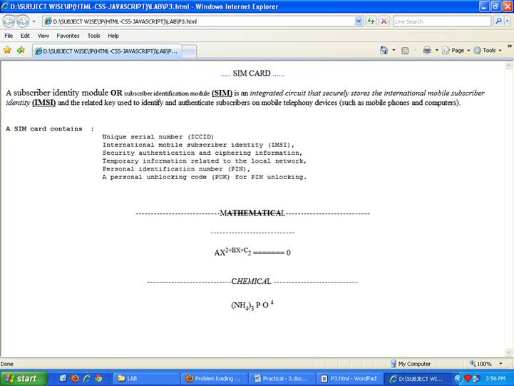

**7.**Write HTML code to develop a webpage which covers all the tags of this practical and practical-2 also.